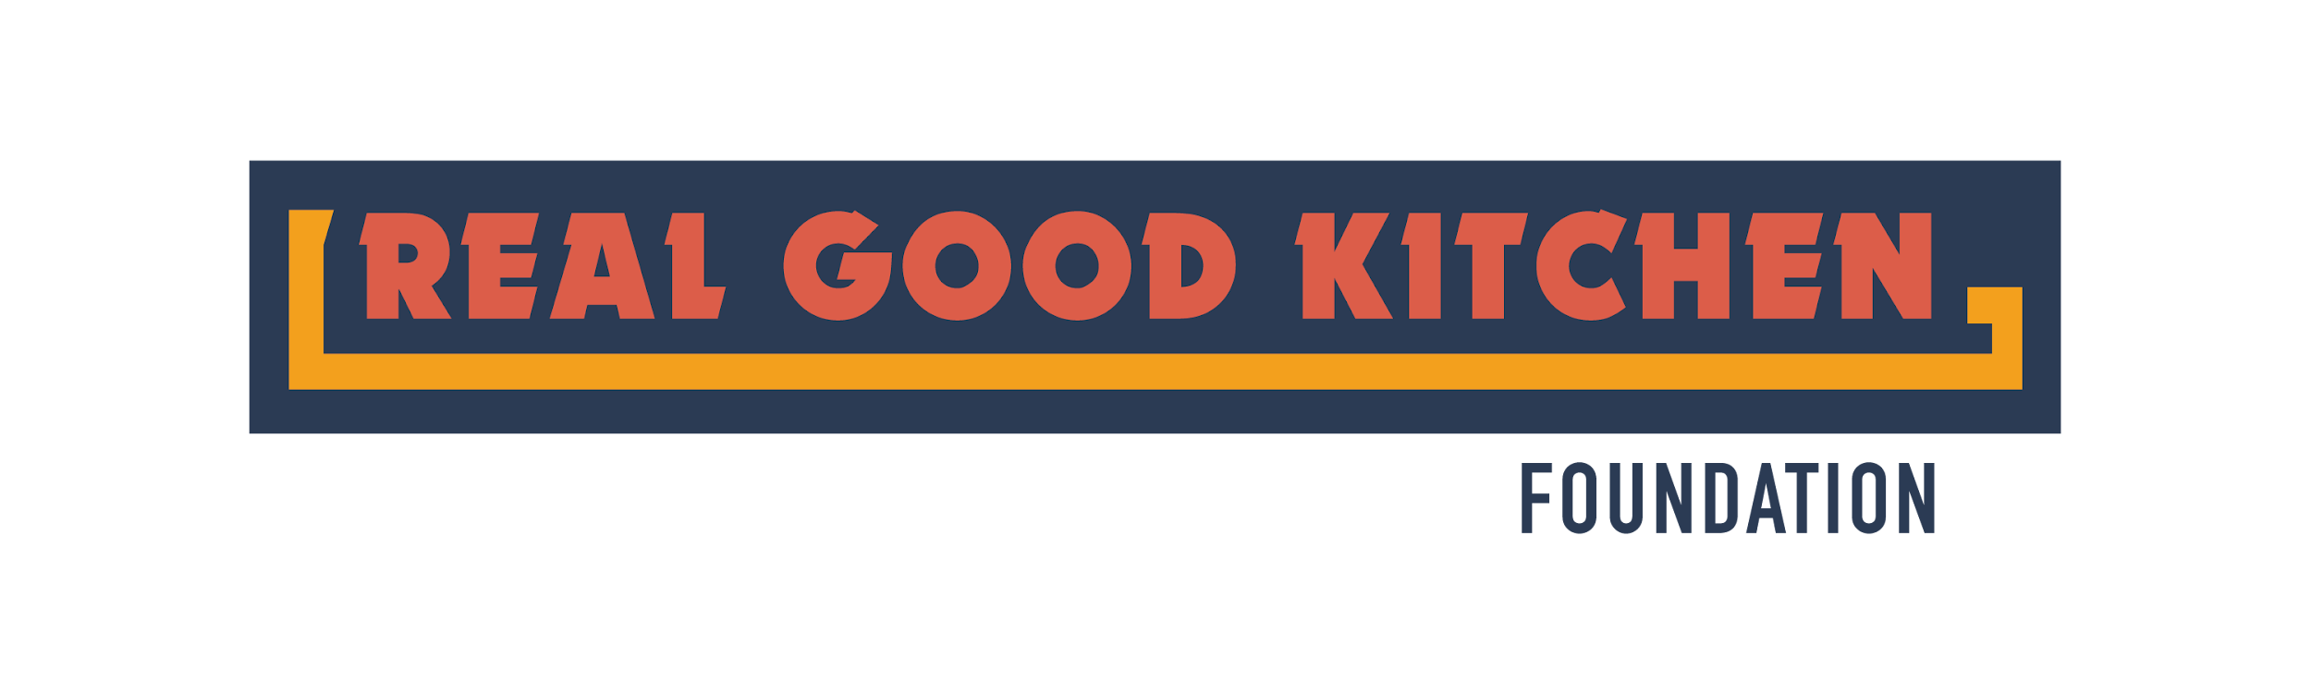

Feasibility Study
The following exercise is a simulation of the questions that we are likely to ask at your potential interview. It’s not important that you have a “right” answer to the questions below, but, rather, that you have shown that you have taken the time to think about these very important questions. We want to see that you’ve begun to think about how your business is going to grow and flourish.

These questions are born out of the biggest mistakes that businesses make and honest answers are going to be the key to business readiness.

Your Business, Competition, and The Local Market

- Describe what product(s) your business makes or will make.

- Briefly describe what inspired you to begin your business. What was the idea or conversation that made you want to sell your product(s)?

- Identify your 3 major competitors. Tell us as much about them as you can. Who are they? Where are they? Etc..

- A competitive advantage is a business term that identifies differences between similar companies. That can be nearly anything, but it’s important that you know what makes you different from someone else. What, if anything, do you think is your competitive advantage?

- How many other businesses in the area sell what you sell or plan to sell? How did you find this out?

- What’s the average price point for your product?

Sales Channel
Sales channels, or distribution channels, are the way that you will deliver your product to your customer. This is one of the most important things to think about, as it will shape everything about your price structure and business model. Please try and answer the questions critically.

- If you’re already selling: Who are you selling to? Where are you selling? What are you charging for your products?
If you are not yet selling: Who will you sell to? Where are you doing to sell your products? How much do you plan to sell them for?

- Will you need to deliver or transport your product to your customers? If so, how are you going to deliver or transport your products?

- How often do you imagine that you will be delivering your product in the next year?

Resources
We know this part can be hard. Your aim as a business is to make money and in order to know if you are, you’ll need to track and understand your business finances. We want you to consider what it will take before investing more resources in your business. Please try to be honest and get assistance from community resources. We are looking for realistic visions in the application process.

- In an ideal world, how much would you like to pay yourself per year through your business?

- How much do you think this means that you will need to sell per year?

- How much time do you have to spend on your business right now? (hours per week or per month)

- If you are currently working another job, at what point (amount in business sales) would you imagine leaving your other work and focusing entirely on this business? If you are currently operating part time, when do you imagine running this business full time?

- How much capital do you think you will need for the next year? If you are just getting started, please provide a detailed list of your start-up costs for your first year. If you are already in business, please provide a list of what you expect to invest in over the next year.

- How will you get the capital needed for the costs above?

- Do you have employees? If so, what do they do? How much do they cost you monthly (consider hourly wages and workers’ compensation/benefits)?
If you do not have employees yet, when do you anticipate hiring your first employee? How much do you think they will cost you monthly (consider hourly wages and workers’ compensation/benefits)?

- What personal, professional, financial, and support resources do you currently have available to you?

Long-Term Vision
One of the hardest things to do is to start a business. We understand that, but once you start your business you will also need to grow. In this section, we ask you to imagine how you will grow your business.

- What are your 3 business priorities in the next year?

- How will you measure success for your business? Please explain both personally and financially.

Exit Strategy
Real Good Kitchen Foundation is a business incubator. This means that it is a place to grow your business, but also that at some point, you will need to fly out on your own without the support of the incubator program even if you stay in the Real Good Kitchen. The following questions are intended to examine what you imagine that path might look like.

- What will need to happen for you to feel like you’re ready to graduate from the Food Business Incubator Program? Please be as detailed as possible.

- What do you imagine is the next step after you graduate? What will you need to get there? (Money? Real estate? etc.). How long do you think it will take for that to happen?

- Do you imagine being a local business, a regional business, or a national business?

- We are a small team who works with the support of community resources and business owners who share their expertise. Do you envision continuing to support the Real Good Kitchen Foundation and/or the Food Business Incubator program once you graduate? How?

